Correlations of Oral Health Practices Implemented at the Head Start and WIC Programs in Las Vegas, Nevada

Lily Hoang, DMD, MBS, Christina A. Demopoulos, DDS, MPH, Connie Mobley, PhD, RD

ABSTRACT

Introduction:
This study compares correlations of oral health practices among participants in Woman, Infants, and Children (WIC) and Head Start educational programs and children’s oral health status.
Methods:
A convenience sample was recruited from participants in the University of Nevada, Las Vegas (UNLV) School of Dental Medicine (SDM)/Seal Nevada South (SNS) Program. Parents of children who participated in the SNS program completed a medical history form identifying participation in WIC or Head Start during intervals ranging from 1 to 3 years. Results of oral health screenings classified children into the following categories: Untreated decay, caries experience, sealants present and treatment urgency.
Results:
A total of 106 (49.8%) parents had participated in WIC or Head Start while an equal number had not participated in either program. Almost half of the children were documented as having early dental care needs (N=97, 45.5%). Children of parents in the non-participating group had less untreated decay (N=54, 43.9%) when compared to children of parents in the participating group (N=69, 56.1%).
Discussion: Dental caries is highly prevalent in children aged six to nine irrespective of participation in an oral health program. Evidence-based prevention strategies must be reconsidered especially for children identified as high risk for caries.
Key Words: WIC, Head Start, Oral Health Education, Prevention

INTRODUCTION

Dental caries is the most prevalent chronic childhood disease in the United States, five times more common than asthma (Poland & Hale, 2003;Vargas, Crall, & Schneider, 1998). According to Wachino (2011), nationwide, children enrolled in Medicaid carry the greatest burden of oral diseases with 25% of low income children currently accounting for 80% of reported dental disease (Wachino, 2011). According to the Department of Health and Human Services, Division of Public and Behavioral Health, Oral Health Program report titled, “2008-2009 Third-Grade Oral Health Survey,” six out of ten (65%) of Nevada’s third grade students had tooth decay, 12% higher than the national average (53%) [Department of Health and Human Services, 2008]. In the 2011 – 2012 Nevada’s Head Start Oral Health survey titled, “Healthy Smile, Happy Child,” there were two specific health objectives and comparative measures for 2020 (Department of Health and Human Services, 2011):

- Objective 1: “Reduce the proportion of young children with dental caries experience in their primary teeth.” The Healthy People 2020 target is 30% with caries experience.
- Objective 2: “Reduce the proportion of young children with untreated dental decay in their primary teeth.” The Healthy People 2020 target is 21.4% having untreated decay.

Nevada has not achieved the target for the first objective but has achieved the target for the second objective. Nevada exceeded the target for Objective 2 with a prevalence of 12.3% for untreated decay. In order to meet Objective 1 by 2020, Nevada must reduce the prevalence of caries experience (presence of cavities or presence of filled teeth/treated cavities) by 36.3%, dropping from 47.1% to 30%.
Oral diseases are progressive and difficult to manage if left untreated, but are preventable. Numerous programs across the State of Nevada have been working to improve children’s oral health through education, prevention, and increasing access to dental care. Two popular programs include Women, Infants and Children (WIC) and Head Start which share a common goal: To promote positive health and nutrition status of young families (United States Department of Agriculture, 1999).
Both programs receive oral health education in family meetings with the staff that are offered once a year. The parents and children are in attendance. The WIC and Head Start centers provide toothbrushes and toothpaste to encourage the children to brush after lunch.
Early screening and prevention programs such as those provide by WIC and Head Start have the potential to prevent Early Childhood Caries (ECC). This study compared the correlations of oral health practices among WIC and Head Start participants and non-participants of either program on the oral health status of a children’s cohort in Nevada.

METHODS

Subject Recruitment:
WIC is one of the largest providers of services to low-income young children who may be at high risk for developing dental decay (Center for Oral Health, 2011). According to the Center for Oral Health, WIC is the entry point for oral health assessment, preventive services, and referral for regular follow – up care. WIC partners with public health clinics, community health clinics and private dental practitioners to provide onsite oral health services and access to care to WIC participants. The minimum services recommended include (Center for Oral Health, 2011):
- Caregiver Oral Health Education
- Caregiver Oral Health Interview
- Tooth brushing with the Child
- Oral Health Assessment of Child
- Fluoride Varnish Treatment for the Child
- Anticipatory Guidance and Goal Setting with Caregiver
- Refer / Arrange for Ongoing Care or Treatment
These services typically take 15 to 20 minutes per child for the initial visit, and afterwards, collaboration with public health organizations, Federally Qualified Health Centers (FQHCs), community dental clinics, and private dental practices are needed to establish a dental home for diagnostic and preventive services and any treatment needed (Anselmo, McClure, & Russell, 2012).
The Head Start program helps parents obtain oral health examinations and follow – up care. The Head Start staff is required to track the provision of oral health care to children (i.e. establishing a dental home and following the Early and Periodic Screening, Diagnostic, and Treatment Program [EPSDT schedule]) (Holt, 2011). Head Start’s basic screening guidelines include indications of any of the following (Department of Health and Human Services, 2007):
- Sound teeth (teeth without decay, restoration or sealants)
- Obvious signs of decay
- Restored teeth, indicating previous caries experience
- Pain and swelling
- Treatment urgency
Information about examination results, plans for care, treatment completed and prevention activities are kept in a child’s health record (Holt, 2011). This program also promotes good dental hygiene in the classroom (i.e. brushing after meals). Each day, staff wipes the infants’ gums and assists children in brushing their teeth with fluoridated toothpaste, which occurs in conjunction with provision of nutritious meals and snacks (National Center on Early Childhood Health and Wellness, 2015). The Head Start staff knows that the parents / caregivers are a key component to the child’s health and developmental needs. The staff helps parents / caregivers to understand the benefits of prevention and proper health care, along with the importance of establishing a dental home early in life.
This research study included a convenience sample of two cohorts of subject volunteers who participated in the University of Nevada, Las Vegas School of Dental Medicine/Seal Nevada South (UNLV SDM SNS) Program representing both retrospective and prospective data. Cohort I represented retrospective data taken from records of approximately 86 de-identified subjects who participated from February 10, 2015 to June 24, 2015. Cohort II included prospective data from subjects who participated and consented from October 15, 2015 to May 26, 2016. This study was approved by the University of Nevada Las Vegas Institutional Review Board (Protocol #751838-1).

Instrumentation:
Cross-sectional data from two points in time with the aforementioned cohorts (I and II) were documented for analysis. Parents of children who were enrolled in schools receiving services from the UNLV SDM SNS Program and who consented to participate in this program were asked to complete a medical history questionnaire relating to participation in WIC or Head Start and identified within specific time intervals: Less than 12 months, 1-2 years, 2-3 years, or more than 3 years.
SNS offers free preventive services to Title 1 elementary schools in the greater Las Vegas area with more than 50% enrollment in the Free and Reduced Lunch (FRL) Program. Historically, FRL programs are available in schools with underserved populations and schools with more than 50% enrollment have a greater distribution of minority populations. Every effort was made to recruit a representative distribution of gender, racial and ethnic groups for inclusion in this study. Parents signed informed consent for the child to receive the oral health screening and preventive services. Children that were uncooperative on the day of the visit may not have received preventive services at the school and were referred to the UNLV SDM or a local dentist for treatment.
Dental data utilized in the study were collected through oral health screenings performed by SNS faculty (dentists and dental hygienists), dental hygiene students, UNLV pre-doctoral dental students and UNLV pediatric dental residents. All SNS faculty were calibrated (standardized to the screening process to achieve a precise measurement each time) using a Basic Screening Survey (BSS) tool provided by the Association of State and Territorial Dental Directors (ASTDD) annually. SNS faculty instructed and mentored the students and residents to ensure consistency. The dental hygiene students watched a video as part of their assessment training at the College of Southern Nevada. SNS used the BSS as a Best Practice approach for community needs assessments and public health surveillance. The oral health screenings were based on visual assessment of the child’s teeth. Data recorded for each consented child included weighted categorical descriptions of dental status as follows: untreated decay (having cavities), caries experience (having cavities or fillings), presence of sealants, and treatment urgency (Table 1). No obvious problem was defined as a child that presented without evidence of untreated decay/cavities. Early dental care was defined as a child that presented with untreated decay and was in need of follow-up care within the next several weeks or before their next regularly scheduled dental appointment. Urgent care was defined as a child that presented with pain, infection or swelling and was in need of follow-up care between 24 and 48 hours.

Table 1 – Classification of Intraoral Findings in Visual Dental Assessment of Children
Untreated Decay | Caries Experience | Sealants Present | Treatment Urgency
0 – No untreated decay | 0 – No caries experience | 0 – No sealants | 0 – No obvious problem
1 – Untreated decay | 1 – Caries experience | 1 – Sealants present | 1 – Early dental care
 |  |  | 2 – Urgent care

ANALYSIS

Caries experience and evidence of untreated decay were compared between the children of parents who reported participation in WIC or Head Start and those that reported no participation in these programs. Data from subjects included in Cohorts I and II were combined for data analysis purposes. Descriptive statistics were used to demonstrate the frequencies [N-values and percentages] of the results. A Chi-Square test was conducted to determine any association between untreated decay and participation in WIC or Head Start.

RESULTS:

Of the 212 children participating in the study, a total of 122 were females (57.3%) and the average age was 8 years old (45.1%) [Table 2]. A total of 106 (49.8%) parents had participated in WIC or Head Start while an equal number had not participated in either program.
Table 3 below highlights the oral health status of the children participating in the study. The children had a high rate of untreated decay (N=123, 57.7%) and caries experience (N=152, 71.4%). The majority of the children did not have any dental sealants on their first molars (N=153, 71.8%). A greater amount of children were documented as having early dental care needs (N=97, 45.5%) compared to urgent needs or no obvious problem.

Table 2: Demographic Characteristics of Children
Total N (%)
Age
 | 6 |  | 3 (1.4)
 | 7 |  | 64 (30.0)
 | 8 |  | 96 (45.1)
 | 9 |  | 49 (23.0)
Gender
 | Female |  | 122 (57.3)
 | Male |  | 89 (41.8)
Race/Ethnicity
 | White |  | 16 (7.5)
 | Hispanic or Latino |  | 125 (59.0)
 | Black/African American |  | 27 (12.7)
 | American Indian/Alaska Native |  | 1 (0.5)
 | Asian/Pacific Islander |  | 15 (7.1)
 | Multicultural  Other |  | 18 (8.5)  5 (2.4)
 | Choose not to respond |  | 5 (2.4)

Insurance Status
 |  | Medicaid/CHIP |  |  | 117 (55.2)
 |  | Uninsured |  |  | 92 (43.4)
 |  | Chose not to respond |  |  | 3 (1.4)
Note: N=212; Total may not equal to 100% due to missing data

Table 3: Oral Health Status of Children
Total N (%)
Untreated Decay
 | Yes  No |  | 123 (57.7)  89 (41.8)
Caries Experience
 | Yes |  | 152 (71.4)
 | No |  | 60 (28.2)
Sealants
 | Yes |  | 58 (27.2)
 | No |  | 153 (71.8)

Treatment Urgency
 |  | No Obvious Problem |  |  | 84 (39.4)
 |  | Early Care |  |  | 97 (45.5)
 |  | Urgent Care |  |  | 31 (14.6)
Note: N=212; Total may not equal to 100% due to missing data

Children of parents in the non-participating group had less untreated decay (N=54, 43.9%) when compared to children of parents in the participating groups (N=69, 56.1%) [Figure 1]. Children of parents in the participating group also had slightly more urgent care (N=16, 51.6%) and early dental care (N=54, 55.7%) than the non-participating group (N=15, 48.4% urgent care; N=43, 44.3% early dental care) [Figure 2]. A Chi-Square test was conducted to look at any associations between untreated decay and participation in WIC or Head Start. Findings reflect that there is a positive association between these variables (Chi-Square 217.38, df=4, p=0.0005).

Figure 1: Oral Health Status of Children of Parents Participating in WIC /Head Start or Neither Program

Figure 2: Treatment Urgency of Children of Parents who Participated in WIC / Head Start or Neither Program

A total of 106 parents had participated in WIC or Head Start and were asked how long ago they attended the programs. The parents would indicate participation occurred more than 3 years ago (N=53), 2-3 years ago (N=21), 1-2 years ago (N=10), and less than 1 year ago (N=23). The oral health status and treatment urgency were compared according to time intervals [Table 4, 5].

Table 4: Oral Health Status of Children who Participated in WIC or Head Start at a Specific Time Interval
Total N (%)
Untreated Decay
 | More than 3 Years  2-3 Years  1-2 Years  Less than 1 Year |  | 27 (25.5)  13 (12.2)  5 (4.7)  23 (21.6)
Caries Experience
 | More than 3 Years |  | 34 (32.0)
 | 2-3 Years  1-2 Years  Less than 1 Year |  | 14 (13.2)  6 (5.7)  25 (23.6)
Sealants
 | More than 3 Years |  | 16 (15.1)
 | 2-3 Years  1-2 Years  Less than 1 Year |  | 5 (4.7)  0  9 (8.5)

Note: N=106; Total may not equal to 100% due to missing data
Table 5: Treatment Urgency of Children who Participated in WIC or Head Start at a Specific Time Interval
Total N (%)
No Obvious Problem
 | More than 3 Years  2-3 Years  1-2 Years  Less than 1 Year |  | 20 (18.9)  8 (7.5)  4 (3.8)  4 (3.8)
Early Care
 | More than 3 Years |  | 17 (16.0)
 | 2-3 Years  1-2 Years  Less than 1 Year |  | 11 (10.4)  5 (4.7)  21 (19.8)
Urgent Care
 | More than 3 Years |  | 11 (10.4)
 | 2-3 Years  1-2 Years  Less than 1 Year |  | 2 (1.9)  0  2 (1.9)

Note: N=106; Total may not equal to 100% due to missing data

When the WIC and Head Start participants were asked how long ago they attended the program, children of parents who participated more than 3 years ago experienced caries and have untreated decay more than any other time intervals. Participating in the program 1-2 years ago shows the least amount of caries experience and untreated decay [Figure 3]. The more years that have passed since the original participation date, the children have less urgent care; however, children of parents who participated in the programs within a year have the most need for early dental care [Figure 4].

Figure 3: Oral Health Status of Children of Parents enrolled in WIC / Head Start According to a Specific Time Interval

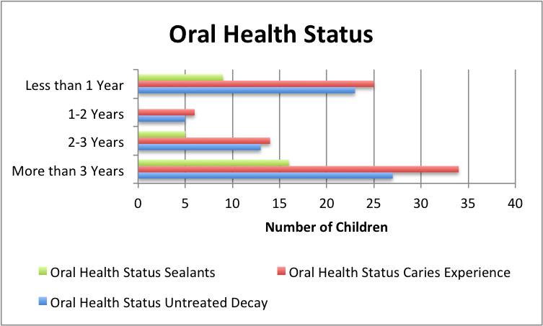

Figure 4: Treatment Urgency of Children of Parents enrolled in WIC / Head Start According to Specific Time Intervals Since Participation Had Occurred

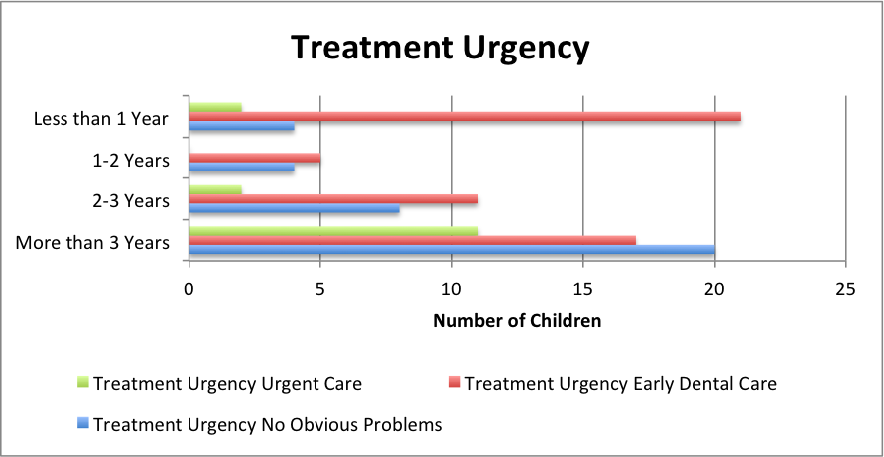

DISCUSSION

Dental caries has been on the rise in the United States among children, especially in low – income populations, and many programs, such as WIC and Head Start, educate families on good oral health practices to help reduce the oral health burden in this population. Previous studies have shown that WIC and Head Start oral health practices have had a positive influence on their participants; therefore, participants in this study should have presented with less untreated decay and less urgent care needs.
This study compared the oral health status and treatment urgency among children who participated in an oral health education program through WIC or Head Start less than 1 year ago, 1-2 years ago, 2-3 years ago, and more than 3 years ago. The findings indicated that children of parents participating in a WIC or Head Start program had the highest rate of untreated decay if they participated less than 1 year ago or more than 3 years ago. Treatment urgency showed great variance between post participation intervals in the educational program. The results showed that there was a higher prevalence of early dental care needs if the parent participated less than 1 year ago or more than 3 years ago compared to those who participated 1 to 2 years ago. Findings suggested that more frequent intervals of presentations should be offered to this population in order to improve the oral health status of the children since urgent care decreased with time and then increased after 2-3 years with an even greater increase at more than 3 years post program participation. This suggested that those who had participated over 3 years ago could have experienced recurrent caries and had forgotten important practices since participating in the program because there was no ongoing access to repetitive practices or education.
There have been few studies examining dental disease in the 6 to 9 year age group in the State of Nevada. This study showed that the children of parents who did not participate in either WIC or Head Start had less untreated decay and less need for urgent care. The findings suggested that the content of the oral health presentations in these programs may not have addressed some of the Social Determinants of Health that affect this population (Crum, 2013). Social determinants such as access to a grocery store with nutritious food options, public transportation, and access to a dental provider may have prevented the parents from fully implementing what they learned in the educational program.
Findings further suggested that not only the frequency, but also content of the oral health presentations could help increase the awareness of good oral health practices for children and families. Repeated encounters with evidence-based educational information from a diverse group of providers may also increase the opportunities to retain the information that is presented. Parents need to follow up with dental providers to create a dental home for their child and to reinforce daily home oral hygiene regimens. This would assist parents in retention of what they learned at WIC or Head Start programs.
All efforts were made to ensure the highest quality results in this study, but there were limitations. First, we had a short duration of 3 years (ages 6 to 9) to assess caries experience. Although there were methodical improvements in the evaluation, future studies are needed for long-term oral health effects. In addition, this study only examined children from the greater Las Vegas area. Expanding the study within several states would give invaluable and precise information for future evaluation and possible implementation of enhanced oral health components in programs. However, due to time and cost, it was not feasible to do so in this study. Further, reported participation within any program may not have been accurate due to self-reported information provided by the parent / caregiver. They may not have accurately recalled enrollment in any program. The providers who participated in this study were trained to standardize the screening process, and the inter-reliability was reestablished throughout the study. However, there could have been inconsistency while collecting data.
The results of this study could be used to develop strategies, policies, and materials for more effective education of WIC and Head Start parents, thus, preventing oral diseases. The results could also help indicate which programs need improved collaboration with healthcare providers to deliver more effective preventive education.

CONCLUSION

- Dental caries is highly prevalent in children aged six to nine irrespective of participation in an oral health program.
- There are no significant differences or improvements in oral health status between children of parents who attended WIC or Head Start programs and those who did not attend either program.
- Evidence-based prevention strategy protocols including oral health literacy education need to be evaluated using a risk-based assessment to ensure compliance with home care and establishment of a dental home.

REFERENCES

Anselmo, T., McClure, L., Russell, S. (2012). WIC Dental Days: A Collaborative Early Childhood Caries Prevention Program. National Primary Oral Health Conferences.

Center for Oral Health. (2011). WIC Early Entry to Dental Care. Oakland, CA: Center for Oral
Health.

Crum, R. (2013). Building Community and Improving Health in Low-Income Las Vegas Neighborhoods. The Robert Johnson Wood Foundation.

Department of Health and Human Services, Division of Public and Behavioral Health, Oral Health Program. 2008-2009 Third-Grade Oral Health Survey.

Department of Health and Human Services, Nevada State Health Division, Oral Health Program. 2011 -2012 Head Start Oral Health Survey, Healthy Smile, Happy Child.

Department of Health and Human Services, Nevada State Health Division, Bureau of Family Health Services. (2007). Head Start Basic Screening Survey Process Evaluation.

Holt, K. (2011). Dentists and Head Start: What You Should Know and How You Can Help (2nd ed.). Washington DC: National Maternal and Child Oral Health Resource Center.

National Center on Early Childhood Health and Wellness. Oral Health Assessment, Follow-Up, and Treatment. 2015.

Poland, C 3rd, Hale, K.J. (2003). Providing oral health to the little ones. Journal of the Indiana Dental Association. 82,8-14.

United States Department of Agriculture, Food and Nutrition Services. (1999). “WIC and Head Start, Partners in Promoting Health and Nutrition for Young Children and Families.”

Vargas, C.M., Crall, J.J., Schneider, D.A. (1998). “Sociodemographic distribution of pediatric dental caries.” NHANES III, 1988-1994. Journal of American Dental Association. 129, 1229-1238.

Wachino, V. (2011). New Directions for Medicaid and CHIP Dental Programs: Children and Adults Health Programs Group, Center for Medicaid, CHIP, and Survey & Certification. Monday, June 27, 2011. Washington DC. Centers for Medicare and Medicaid Services.

